ESE Homework 4 – Recursive Makefile

1. Source code
   1. Main

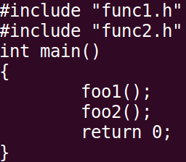

* 1. Headers

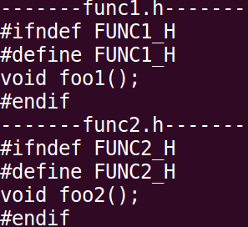

* 1. Sources

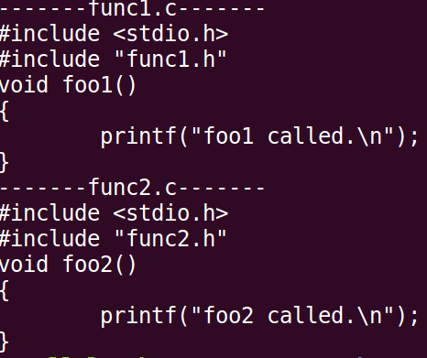

1. Makefile
   1. Top-directory

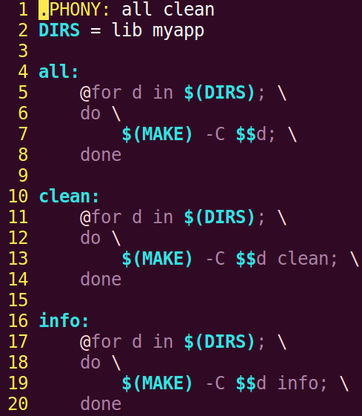

* 1. lib

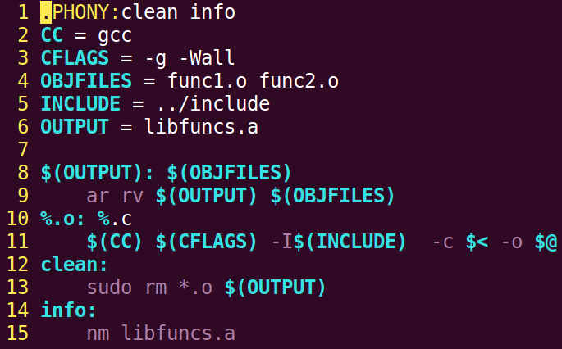

* 1. myapp

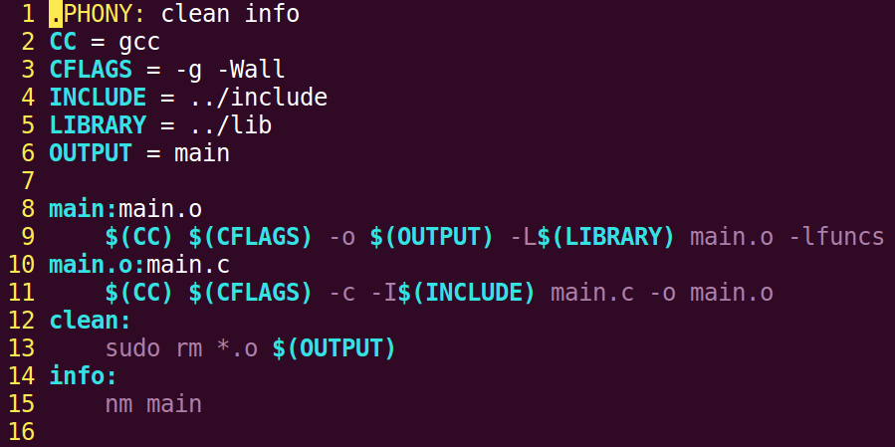

1. Result
   1. make all

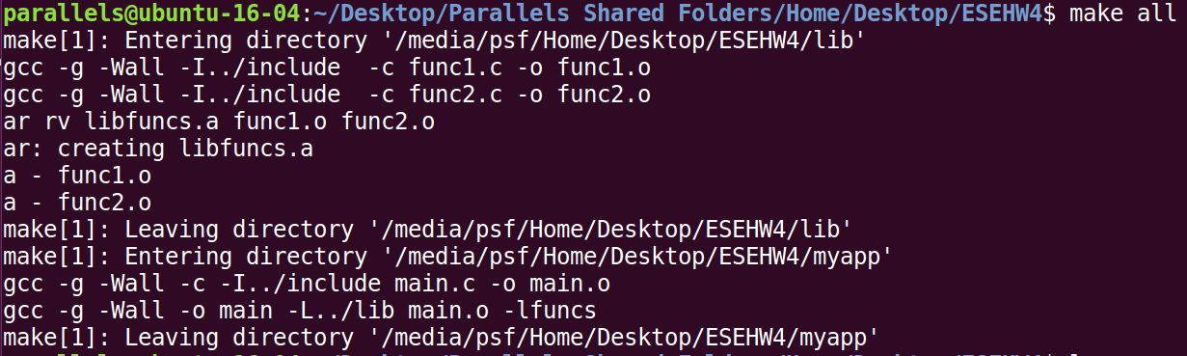

* 1. make clean (After make all)

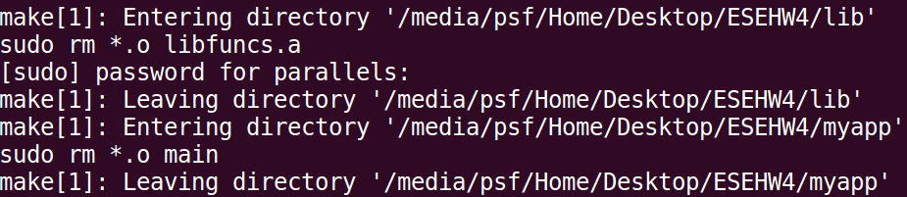

* 1. make info | grep foo (Additional Attempt)
* To check the libraries successfully created and linked.

